# Application life cycle management.

One of our main goals when approaching the life cycle management of our applications is to try and centralize all the aspects related to this management in the fewer number of tools. We will be using GitHub, which gives us the tools required in lots of the processes related to the management.

GitHub will be used for the following tasks:

* Estimation and planning: For each sprint, a Kanban board will be created, showing the tasks that we must work on during the sprint, its deadlines and whose responsibility will be to finish each task.
* Source code management: By using a git repository, we can guarantee an appropriate version control. Our repository will have the following workflow: A master branch with all the source code of our application that will be deployed, a development/integration branch created from this master branch whose function is to integrate and test all the code written by the developers, and branches born from this develop branch which will be related to the different use cases and functionalities that we will be working on.
* Knowledge management: All the documentation related to our project will also be uploaded to the repository. Besides, the repository’s wiki will be the place where all the members will add any kind of information that may be considered relevant for others members when working on the project.

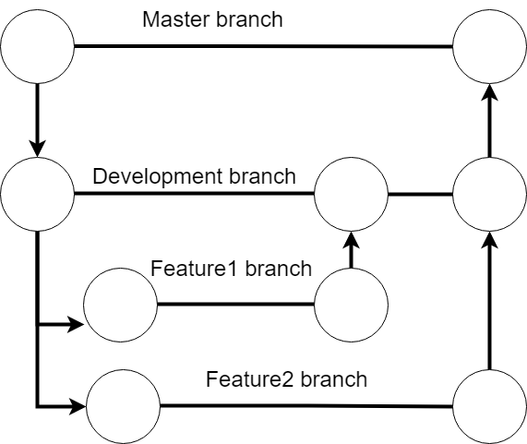

Representation of our repository workflow

There are other tools besides GitHub that will be used, such as Travis CI. Travis CI will be used in order to implement continuous integration and quality assurance in our code. Each time changes are made in our branches, before committing the code, the application will be launched using Travis and some tests will be triggered in order to guarantee the changes made work as intended and do not interfere with other features. Our application is initially planned to be hosted in Heroku. Travis also offers interaction with Heroku deployed applications, which means we will be able to create a pipeline that allows us to automatically update our production server with changes made in the main branch of our repository.

Lastly, as means of communication within the development team, we will be using Telegram to send messages to the rest of the group and Google Hangouts when in need of having online meetings.